**Automatic Fish Feeder**

**200725F – WIJESEKARA W.M.E.P.B.B.**

**200740V – YALEGAMA M.M.O.A.B**

**200741B – YAPA Y.A.N.T.**

Contents

Abstract…………………………………………………………………………………………………...3

Introduction……………………………………………………………………………………………….3

Method…………………………………………………………………………………………………….4

Firmware design………………………………………………………………………………….4

PCB design……………………………………………………………………………………….6

Enclosure design………………………………………………………………………………12

Results……………………………………………………………………………………………………14

Discussion………………………………………………………………………………………………15

Acknowledgement………………………………………………………………………………………15

References……………………………………………………………………………………………….15

**Abstract**

The device we have managed to build is an automatic fish feeder which is a device that can dispense fish food at preadjusted moments of time. The user will have the ability to adjust both the frequency of feeding and the amount dispensed. The microcontroller that we used was programmed using an Arduino UNO development board. The enclosure and PCB were designed on Solidworks and Altium Designer respectively and a preliminary physical prototype was also built to verify the functionality of the circuit.

1. **Introduction**

Our objective in creating the automatic fish feeder was to create a device which would contain the following main features:

1. The Ability to set the frequency of feeding

2. The Ability to set the amount of feeding

3. A mountable and adjustable platform to support the fish feeder

We were able to achieve the necessary outcomes by approaching the project in three different aspects. Each of these aspects were separately inspected and realized by the three members of our group. The three aspects are:

1. Firmware design

The algorithms that are implemented in the user interface and microcontroller, Writing the code for the necessary program

1. PCB design

The schematic diagram of the circuit, The layout of the final PCB, The selection of suitable components

1. Enclosure design

The enclosure that holds the electronic components and the container, The adjustable platform that supports the fish tank feeder

1. **Method**
2. Firmware development

To achieve the necessary features in our device we needed to invent an algorithm that would allow the device to perform the following actions.

1. Set the feeding time

2. Set the amount of feeding

3. Operate the feeding mechanism at the required time

4. Display the configuration on the LCD

5. Obtain the necessary instructions from the keypad

For the microcontroller we chose the ATmega328P microcontroller considering the scope of our project and its technical capabilities. We also decided it was appropriate because of the ease in programming using the Arduino UNO development board which is the method were employed instead of Microchip Studio.

The LCD display we used was a 16x2 blue colour LCD and we used a I2C interface to program the component considering the restriction in the number of pins that could be used. The LCD would display allow the user an interface to see the changes he makes to the feeding configuration in real time. It would display the relevant option being changed as the user is giving inputs to the buttons.

The button configuration was slightly modified to suit the needs of the physical prototype. Instead of the originally planned five button configuration, three buttons will be used with a separately placed switch.

The program to operate the stepper motor, IC and menu were also developed separately and combined when compiling the final program. The microcontroller kept track of the real time using a DS1307 real time clock module.

Hence, it can be concluded that the main sub systems associated with the firmware of our device is the motor, display, keypad, and timing.

|  |  |
| --- | --- |
| Subsystem | Function |
| Motor | Turn the container at the appropriate time |
| Display | Display information to the user relevant to the configuration  Displaying the real time |
| Keypad | Detecting user inputs |
| Timing | Keeping track of the current time |

**Algorithms**

The general algorithm of our device is as follows:

**LCD operation**

|  |  |
| --- | --- |
| **Display mode** | **Function** |
| Home | Default screen |
| Set time | Setting Real Clock Time |
| Feed 1 | Setting first feeding time |
| Feed 2 | Setting second feeding time |
| Feed 3 | Setting the third feeding time |
| Set turns | Setting food dosage |
| Test Feed | Testing the feeding |

|  |  |
| --- | --- |
| **Button** | **Function** |
| On/ Off | Switching on or off the feeder |
| Menu button | Go through the menu |
| Hour button | Set up hours in set time and set hours in feeding time |
| Minute button | Set up minutes in set time and minutes in feed times. |
| Reset | Resetting the program |

1. **PCB Design**

**List of components used:**

Before the PCB design could be initiated, we had to consider the approach we took for the circuit. First, the specific components and parts that we used had to be decided. Considering both the scope of our project and other constraints such as budget and space allocation, the following are the components we decided to use.

General components

1. ATmega328P microcontroller
2. DS1307 RTC IC
3. 16MHz and 32768KHz oscillator
4. Through hole Electrolytic Capacitors (22pF and 100nF)
5. Through hole resistors (4700)
6. 2 pin headers for the power supply

Keypad

1. 3x push buttons
2. Switch

Display

1. 16x2 blue colour LCD character type display(1602A)
2. I2C module

Timing

1. DS1307 IC
2. CR 2032 Battery

Motor

1. ULN2003AN motor IC
2. Stepper Motor

**Reasoning for the use of specific components**

The components were generally selected with a though hole type of mounting to enable a physical prototype to be tested prior to the PCB implementation. We originally had the intention of using a servo motor but due to the lack of availability and the similar functionality, we decided a stepper motor would be more appropriate. An I2C module was used to connect the LCD to the ATmega328P microcontroller to satisfy the constraint in the number of pins available. The pin configuration of the microcontroller is seen below:

**Considerations in PCB design**

1. Generally, the shortest paths were taken between components
2. The width of the power tracks was made wider (1.8mm) than the normal tracks (0.85mm) where possible.
3. The PCB had to fit the dimensions of the enclosure(maximum 10 cm x 10 cm)
4. The PCB was routed in two different layers to avoid crossing of two traces.
5. All headers were connected at the edge where possible to allow ease of wiring
6. For the prototype it was decided to have the button configuration separately (connecting with J1 in the figure)

The Schematic, PCB Layout and a 3d view of the layout are demonstrated below:

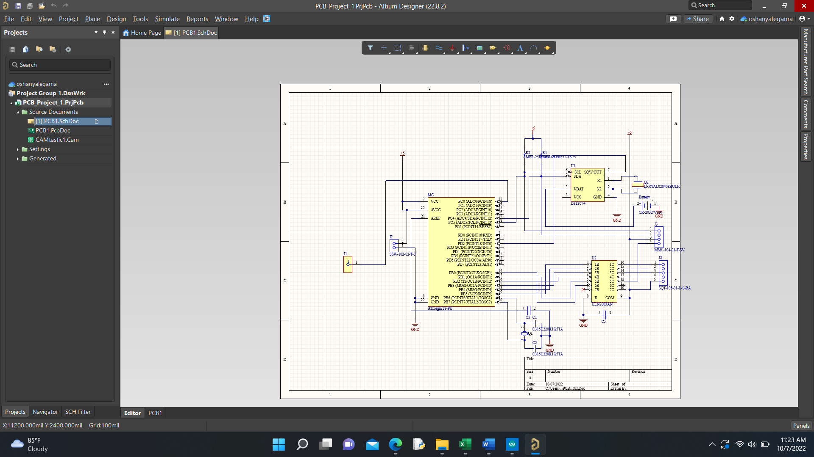

1. Schematic Diagram

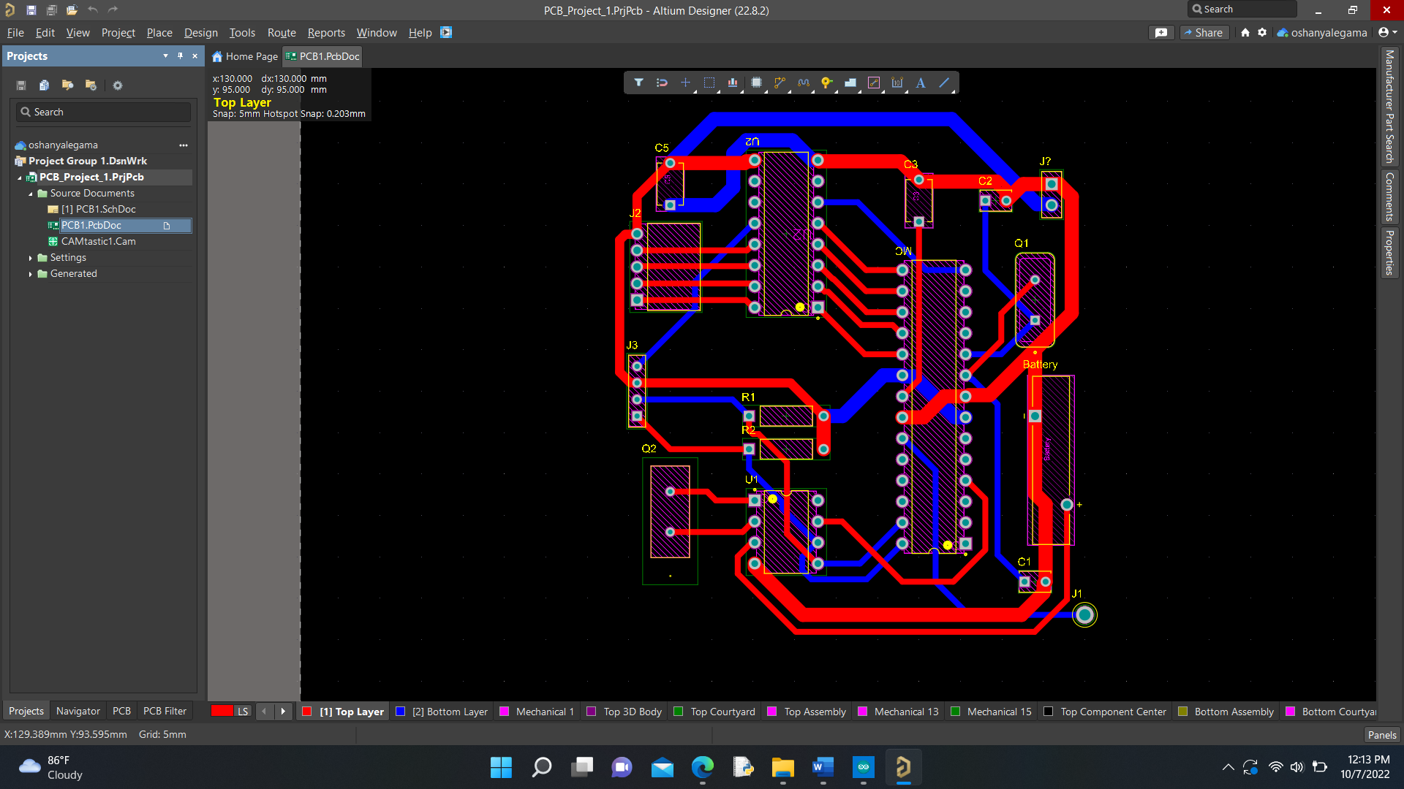

1. PCB layout(both)

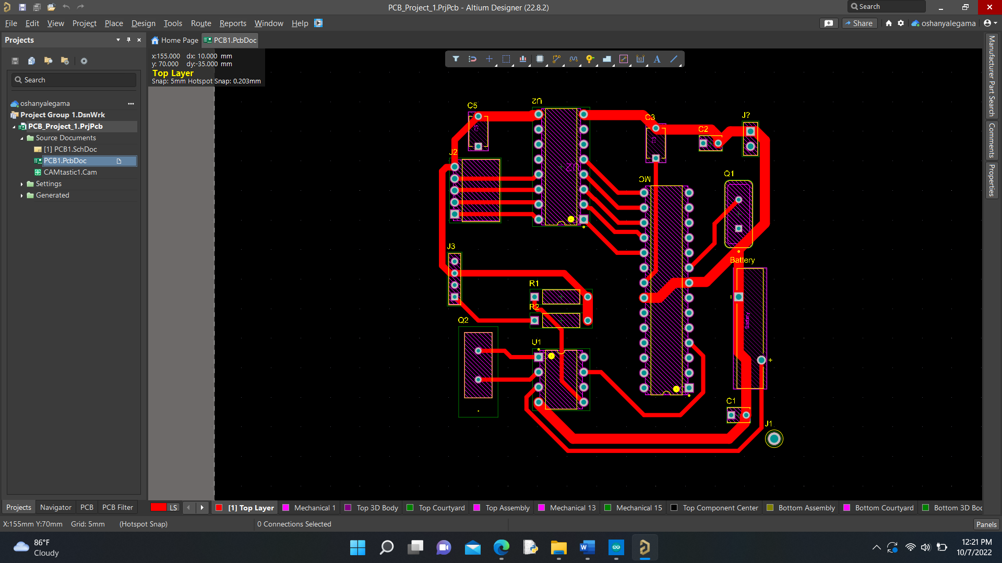

1. PCB layout(top)

d)PCB layout(bottom)

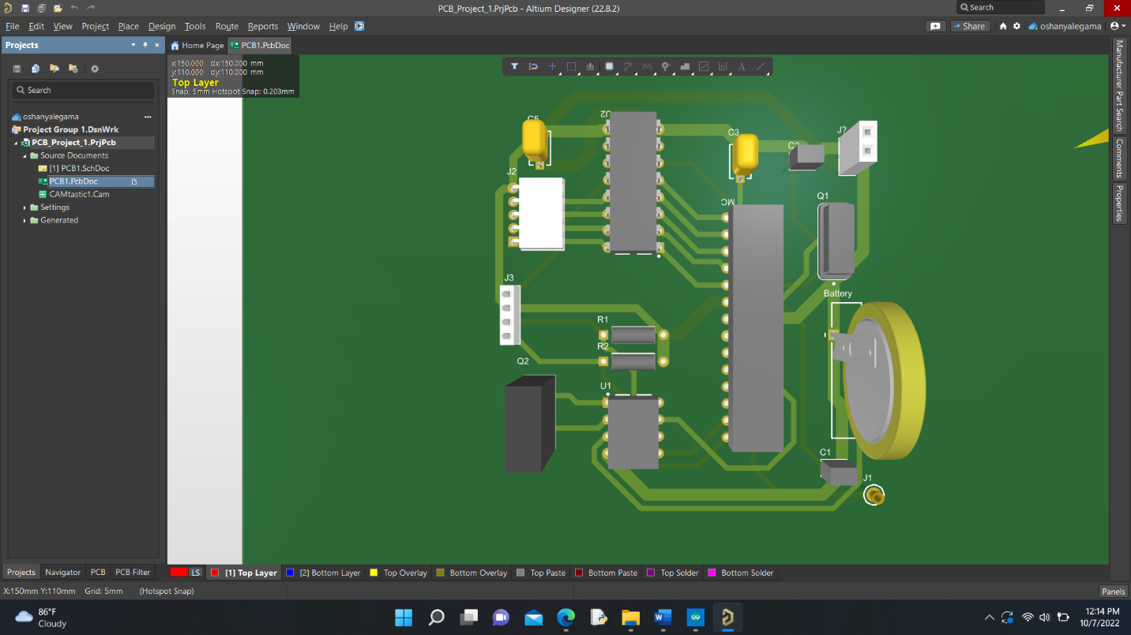

e)3D view of PCB layout

1. **Enclosure design**

The design of the enclosure was an especially important aspect since it involved the careful consideration of dimensions and shape to suit the needs of both the strength and attractiveness necessary.

1. Fish food compartment

The fish food will be contained in this enclosure, and it will directly connect with the compartment shown below.

1. PCB and User interface compartment

The PCB and will be inside this compartment while the LCD will connect with the rectangular region shown in the figure. It will rest on top of the adjustable platform and will also hold the stepper motor that will rotate the rotating drum

1. Rotating Drum

The rotating drum will turn at the appropriate time to dispense fish food to the fish tank at the relevant time.

1. Adjustable Platform

The above shown components will be combined to create a platform that can rotated about the attaching part (last figure). The compartment holding the PCB and other components will rest on this platform.

1. **Results**

A physical prototype prepared using laboratory equipment was tested separately to ensure the functionality of the circuit before implementing the PCB and enclosure. The setup used is shown below.

The operation of the prototype can be viewed using the link in the reference. As demonstrated in the video, the circuit managed to deliver the required objectives. After the user sets the time of feeding (which he can set by toggling using the three buttons), the user is then given the option of choosing the feeding dose. Afterwards, he can ensure the functionality of the device by using the test button.

1. **Discussion**

When we first came up with idea for the project it was inconceivable how challenging the project would turn out to be. Even though we managed to have a clear objective regarding the functions of the device we wanted to create, there were numerous challenges in implemented our idea to a working physical device. The restrictions in cost and availability were huge factors. However, we were able to compensate by selecting alternate components. There was also a steep learning curve we had to go through to acquire the knowledge to develop this product. We tackled this issue by dividing our tasks among our members and we believe it’s this method was successful.

1. **Acknowledgement**

We would like to express our gratitude towards all the lecturers who offered use their guidance throughout the development of this project.

1. **References**

*Video demonstration of prototype and References*

<https://drive.google.com/drive/folders/1vMsjd7PS_32J6aVECKei2_1M61RaElO2?usp=sharing>